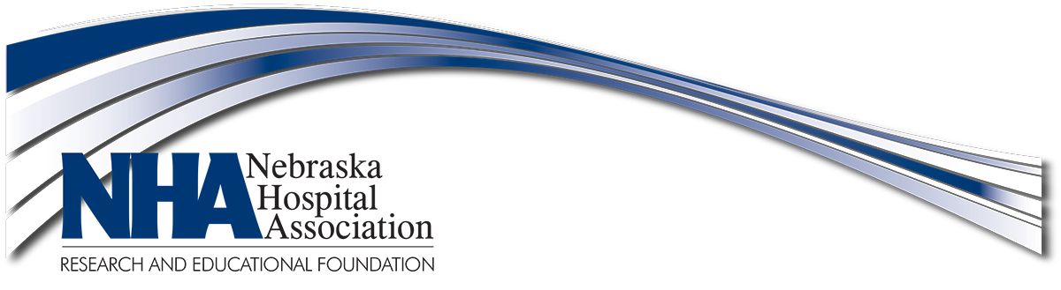

NHA Leadership Institute –Class XVI Opening Retreat Agenda

Lied Lodge & Conference Center

Nebraska City, Nebraska

January 18, 2019

1:30 p.m. – 2:15 p.m. Convene Retreat Jon Titus
Welcome & Introductions

2:15 p.m. – 2:45 p.m. 360◦ Assessment Mike Freel

2:45 p.m. – 3:15 p.m. Coaching Sessions Overview Vickie Seitner
3:15 p.m. – 3:30 p.m. Break

3:30 p.m. – 4:25 p.m. Leadership Institute Overview Brian Noonan
- On-site Sessions Faculty
- Reading Materials
- Coaching Sessions w/Vickie Seitner
- Portfolio
- Expectations

4:25 p.m. - 4:30 p.m. Announcements

4:30 p.m. – 5:30 p.m. Free Time

5:30 p.m. – 6:00 p.m. Social Time
(beer, wine and soft drinks available)

6:00 p.m. – 8:00 p.m. Group Dinner
(Bellevue faculty and class member spouses/guests invited)

(over)

January 19, 2019

7:30 a.m. – 8:00 a.m. Continental Breakfast

8:00 a.m. – 8:30 a.m. Class XVI Connectivity Brian Noonan
- Connections with NHA
- Download Center/Emails
(agendas, handouts, PPTs, etc.)
- Mentorship Program
- Alumni Activities
- Lodging information
- Group dinners & RSVP
- Hospital Tours (8 am) & RSVP
- Keeping in touch via social media in between sessions.

8:30 a.m. – 10:00 a.m. Building a Foundation of Leadership Mike Freel

10:00 a.m. – 10:15 a.m. Break

10:15 a.m. – 11:45 a.m. Session Continues Mike Freel

11:45 a.m. Questions/Adjourn

Next Session:

Round and Round: Using 360ᵒ Assessments for Improved Leadership
(Brewster Session)
February 13, 2019
9:00 a.m. – 4:00 p.m. CT
Great Plains Health
North Platte

