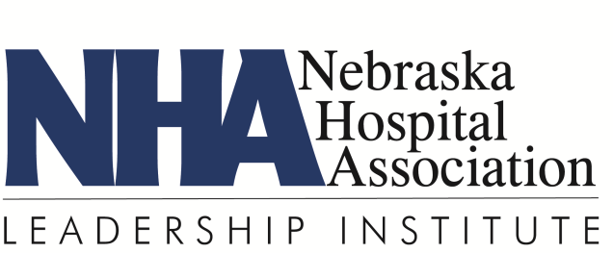

FAX BACK

Isaacson Session Dinner & Tour – West Point

Yes I plan to attend the LI dinner at JD’s Bar & Grill on May 14 at 6:00 p.m.
No I will not be able to attend the dinner

Yes I plan to attend the hospital tour on May 15 at 8:00 a.m.
No I will not be able to attend the tour

______________________________________________________
Name

______________________________________________________
Hospital/Health System

PLEASE REPLY ASAP to:

Heather Bullock
Nebraska Hospital Association
3255 Salt Creek Circle, Suite 100
Lincoln, NE 68504
FAX: (402) 742-8191
hbullock@nebraskahospitals.org

