Dear Hospital CEOs, Chief Nursing Officers, Discharge Planners and Social Workers:
The Nebraska Association for Home Healthcare and Hospice is reaching out to Nebraska’s hospitals to offer collaboration with the hospitals during the COVID-19 crisis. Our home health agency members are willing and available to partner with your members in transitioning patients from the hospitals to their homes for acute care and long-term care services as well as other care needs. Social isolation is best at home to quarantine people and prevent unnecessary infection and contamination by others.
This will help free up hospital beds if hospitals reach capacity. If patients are capable of being at home, then our home health agencies can deliver the care with patient protective equipment (PPE).
We are reaching out to recommend a standard policy and procedures for Nebraska hospitals and home health agencies during the COVID-19 pandemic, to help ensure that patients are being discharged to the best location possible to ensure their health and safety. Following is a suggested policy and procedures:
- Work closely with the patient’s physician, pharmacy, home health agency and other parties to determine the patient’s immediate and ongoing healthcare needs.
- If the physician determines that home health is needed, the hospital discharge planning team would provide referral information as they do today, with special attention to:
  - COVID-19 testing results
  - Information about COVID-19 presumptive or confirmed contacts
  - Caregivers / household members
  - Special Isolation/infection precautions related to airborne while in hospital
  - Respiratory status
  - Aerosol generating procedures
  - Oxygen needs
  - Lab work orders
  - Infusion therapy needs
  - Code status
  - Most recent vital signs (just prior to discharge) including temperature.

For COVID-19 patients, the home health agency will continue to track and monitor the patient’s temperature and respiratory symptoms, including pulse oximetry as available to the individual agency. For many agencies, vital signs can be monitored through telehealth to help limit provider contact with the patient.
There are many opportunities to help reduce risks for patients and keep them safe and isolated at home. Attached for your reference is a list of our home health agency members. You are encouraged to reach out to them and discuss how to best collaborate and serve patients in your local communities.
If we can be of service at any time, please reach out to me at (402) 342-5566 or jsummerfelt@vnatoday.org or Janet Seelhoff, our Executive Director, at (402) 423-0718 or jseelhoff@assocoffice.net.
We are in this together to protect and serve Nebraskans. Thank you for your consideration.
Respectfully,
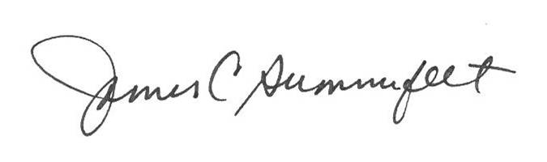
James Summerfelt
Nebraska Association for Home Healthcare and Hospice

