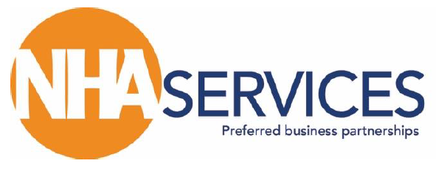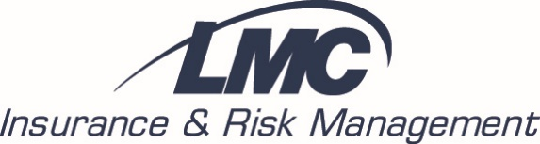

SAFETY COMMITTEE MEETING
March 5, 2019
2:00 pm (Central) via Conference Call

MEMBERS

CARRIERS
Chris Caton, Argent
Rhonda Kraft, United Heartland
Toby Tortorilla, SFM

NHA/LMC STAFF
√ Jon Borton, NHA
√ Pat Duff, LMC
√ Elizabeth Kain, LMC
√ Chuck Martinek, LMC
Ford Singbush, LMC

√ Dena Anderson, Annie Jeffrey Health Center
√ Tammy Claussen, Tri Valley Health System
√ Mike Harris, Chadron Community Hospital
√ James Koteman, Box Butte General Hospital
√ Corey Mann, Memorial Health Care Systems
√ Sandy Noffsinger, Dundy County Hospital
√ Abby Stewart, Fillmore County Hospital
√ Jeanne Temme, Boone County Health Center
√ Shannon Weinman, Community Medical Center

√ Denotes attendance

MINUTES

CALL TO ORDER Jon Borton called the meeting to order at 2:00 p.m. (Central)

ROLL CALL/INTRODUCE ATTENDEES A roll call was conducted of the committee members on the call (attendance noted above).

REVIEW OF COMMITTEE MISSION The current Safety Committee mission statement and responsibilities were distributed to committee members before the call. Chuck Martinek asked for feedback on the mission statement, inquiring if the committee was still ok with it. The group confirmed that it was fine and suggested to keep it as is.

MAY 8/9 SAFETY SEMINARS DISCUSSION Locations have been confirmed for the upcoming Spring Safety Seminars. The North Platte meeting will be on May 8, 2019 and the Lincoln meeting on May 9, 2019. Chuck Martinek shared that the decision was made to have only one meeting a year because of numerous conflicts with other meetings/events happening in the Fall. He asked the committee if having just one meeting in the Spring was still acceptable. Committee agreed with no opposition. The committee also discussed a start time for the meetings. Since there will only be one meeting per year they approved beginning at 9:00 a.m. vs. 10:00 a.m.

MINUTES (CONTINUED)

It was shared with the committee a representative from the State Fire Marshal’s office was confirmed for the Lincoln meeting and was being worked on for North Platte. A representative from the Fire Marshal’s office will speak on Life Safety Issues/Updates. It was suggested that these individuals also discuss matters pertinent to Plant Managers. Other topics the committee suggested for the agenda included:

- Combative patients, assaults on staff, violence against health care workers (Elizabeth Kain from LMC has been speaking on this with Nebraska hospitals. She has two versions, one HR-focused and one more for nurses/aides. She suggested the HR one would be more appropriate. Chuck noted that Elizabeth was available to present these topics in-person at any hospital utilizing LMC).
- Security cameras (this would be covered in combative patient presentation, touching on security features but without specific product recommendations.
- Panic buttons/discussion on common language
- Night Staff – having a skeleton crew working with no security – best practices for protection
- Presentation by Jenny Obermier, senior vice president, COO, CNO at York General about incident in their ER. Post-incident review, how security systems were defeated by staff.
- Legal – job descriptions – what is needed for employees, ADA guidelines
- Current workers comp case review/denials of workers comp claims (employee education)
- Accident prevention topic: muscle strains, lifts/falls, etc.
- Bloodborne pathogens/changes to bloodborne pathogen standard/Hepatitis B vaccination – suggested speaker Laurie Walrod, Perkins County Health Services)
- Accident investigation
- Construction/building projects – risk and safety issues
The committee narrowed this list down to 5 topics for the seminar agenda. 1) Fire marshal’s life safety presentation, 2) combative patients, 3) legal issues/work comp case review, 4) bloodborne pathogens and 5) construction/building projects – risk and safety issues

MINUTES (CONTINUED)

ELECTION OF 2019 OFFICERS The question was asked by the committee why officers are needed. Chuck Martinek shared that it was important for there to be a designated Chair leading the committee that was not an NHA or LMC staff member because the Safety Committee is representing the members. Staff can set up meeting arrangements, but it is important to have someone grant approval, represent committee, approve information before it is distributed and just in general be available for staff to bounce ideas off. Regarding the position of Secretary and taking of meeting minutes, Jon Borton was asked if a support staff member from the NHA could be available to take meeting minutes. Jon indicated that this could be arranged. LMC staff will update the committee responsibilities, roles of the Chair, etc. and distribute that back out to the committee members. James Koteman from Box Butte General Hospital volunteered to be the committee Chair for 2019.
FREQUENCY OF COMMITTEE MEETINGS Chuck Martinek shared that the Safety Committee used to meet quarterly. He proposed having two meetings per year. A Spring meeting to set up the Spring Safety Seminars and a Fall meeting to set up a schedule of educational topic items to send out periodically throughout the year and address any other additional business. The committee agreed to this. The Spring meeting will be held in-person for those available with conference calling as an option. This meeting would be held before the start of the Safety Seminar and will rotate yearly between North Platte and Lincoln. The Fall meeting will be held in October/November via conference call.

OTHER BUSINESS Chuck Martinek introduced Elizabeth Kain, Loss Control Consultant for LMC. Chuck will be handing over responsibilities of the Safety Committee to Elizabeth soon.

Chuck shared that LMC & NHA need to ensure that the Safety Committee has more notoriety. Suggested articles in the NHA Newsletter on safety-specific topics. Possibly utilize social media opportunities. Examples would be short snippets of information on regulatory updates, general safety issues, loss prevention, etc. The committee was supportive of these suggestions.

It was shared that the carrier representatives from Argent, United Heartland and SFM had prior commitments and were unable to join the conference call today. They will however be participating Safety Committee activities.

MINUTES (CONTINUED)

OTHER BUSINESS (continued) Related to the bloodborne pathogens topic discussed earlier there was a discussion regarding needlestick exposures. Chuck Martinek said he would collect from the hospitals the number of incidences on sharps logs/total number of staff hours worked and then he could run an analysis against other hospitals to determine if a facility has a high, average or low risk of incidents or needlesticks. Chuck will be sending out a confidential summary to those he receives information from (to the committee and all participating LMC hospitals). It was also noted that Chris Caton from Argent could provide a facility scorecard related to this as well.

The suggestion was made to create a Nebraska Hospital Safety Officer Listserv for Safety Committee members, HR, compliance officers and safety staff to serve as a discussion board of pertinent items. Individuals could request to be added to this Listserv. Jon Borton said that the NHA has created Listservs for other groups. He will check into what is required and share that back with LMC staff and the committee.

It was noted that in the committee description it was mentioned that previous committee minutes are stored on the Nebraska Hospital Association website. Jon Borton shared that this was not currently happening, but he would work with the NHA Communications and Marketing staff on getting them added to create an archive. Once that is done he will notify the committee where they can access them.

ADJOURNMENT Having no additional business, the NHA/LMC Safety Committee meeting was adjourned at 3:09 p.m.
Respectfully Submitted,
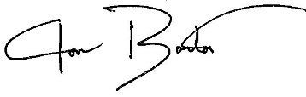
Jon Borton, Vice President, NHA Services
Nebraska Hospital Association

Next Committee Meeting:
Wednesday, May 8, 2019, 8:00 a.m. (Central)
Holiday Inn Express
300 Holiday Frontage Road
North Platte, NE

Minutes prepared 03/07/19

