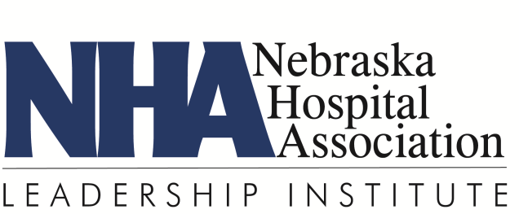

FAX BACK

Brewster Session Dinner & Tour – North Platte

Yes I plan to attend the LI dinner at Canteen Bar & Grille on February 12 at 6:00 p.m.
No I will not be able to attend the dinner in North Platte

Yes I plan to attend the hospital tour on February 13 at 8:00 a.m.
No I will not be able to attend the tour

______________________________________________________
Name

______________________________________________________
Hospital/Health System

PLEASE REPLY ASAP to:

Heather Bullock
Nebraska Hospital Association
3255 Salt Creek Circle, Suite 100
Lincoln, NE 68504
FAX: (402) 742-8191
hbullock@nebraskahospitals.org

