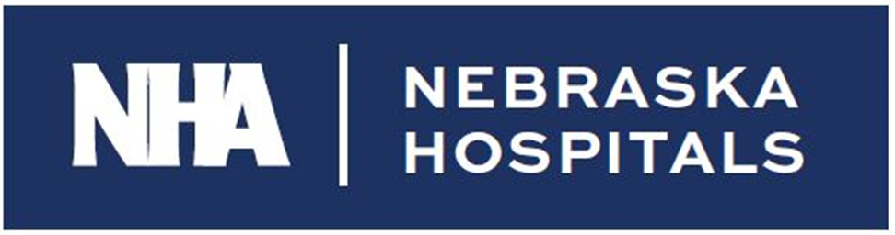

Request for Applications

**2025**

**Quest for Excellence Awards**

**Nebraska’s Health Care Providers: Leaders in Quality**

As a means of recognizing outstanding work in hospital quality and performance improvement in the State of Nebraska, the Nebraska Hospital Association, COPIC, the Nebraska Health & Human Services’ Office of Rural Health and the Nebraska Association for Healthcare Quality, Risk and Safety have come together to solicit applications for the *Quest for Excellence* Award. This award is presented during the Nebraska Hospital Association Annual Convention, which is held in the fall.

The *Quest for Excellence* Award is presented by these organizations to two Nebraska hospitals and one Rural Health Clinic each year to recognize their achievements in improving health care delivery in the areas of quality, performance, and patient safety. Created in 2004 to recognize hospitals’ individual and independent efforts, the award is designed to showcase **innovative, exemplary, and reproducible models** of patient care to the health care community.

The need to demonstrate quality improvement is here… so is this incredible opportunity. Why not take the challenge? Regardless of your organization’s past success, when you submit your application for the *Quest for Excellence* Award, you take another step toward quality and performance excellence.  
  
Statement of Purpose

The *Quest for Excellence* Award recognizes outstanding efforts to improve hospital and clinic quality and patient care for the people of the State of Nebraska. The award represents the highest level of professional acknowledgement in Nebraska’s hospital and clinic quality improvement arena. The goal of the award is to:

* Recognize outcomes in quality performance practices, capabilities, and results.
* Facilitate communication and sharing of best practices information among hospitals and clinics in Nebraska.
* Stimulate innovation, knowledge and learning in the creation of strategies, systems, and methods of achieving quality excellence in health care.

Application Content

To participate in the *Quest for Excellence* Award, an organization must submit an application that addresses the criteria listed below. Entries will be judged by a panel from the five sponsoring organizations. Eligible hospitals and clinics must be able to demonstrate measurable and quantifiable quality improvement. All project descriptions must be double-spaced in 12-point type with 1-inch margins. The document length is limited to 10 pages (excluding cover page). Additional supporting documentation of up to 5 pages may be attached. Only one entry per facility is allowed. Include a cover sheet with the following information:

* Name of organization
* Organization address
* Contact name and e-mail address
* Telephone/fax numbers
* Submission date
* Topic

Submit your entry via email and postal mail.

**1) Email (Word document, not PDF)**

An electronic version of your application and poster (via PowerPoint Template), must be emailed to [mwoeppel@nebraskahospitals.org](mailto:mwoeppel@nebraskahospitals.org).

**2) Postal mail eight (8) copies**

Return via mail postmarked no later than August 1, 2025, to:

Margaret Woeppel, Chief Nursing and Informatics Officer  
Nebraska Hospital Association  
134 S 13th St, Ste 800  
Lincoln, NE 68508-1917

Please include the following categories as you describe your quality improvement activities – include all five categories in your application paper:

# Criteria 1 – Leadership/Planning (10 points)

Describe how hospital/clinic leadership guides and sustains your organization by establishing organizational vision, values, and performance expectations, with a focus on patients, quality improvement, learning, and managing for innovation. Describe how this project is consistent with your strategic plan.

## Criteria 2 – Process of Identifying Need (15 points)

Describe the need in your facility for this initiative; describe why you selected this project and what methods you used to identify the need, e.g., patient/staff/physician satisfaction surveys. What steps did you take to meet your patients’ expectations and requirements? How will this initiative improve the quality of care provided to your patients and your community? Did you integrate your patient/family engagement team? Describe your facility specific issues, as well as providing any applicable national benchmarks or standards.

Was data stratified to assess social drivers and vulnerable populations based on REAL data elements or other metrics that might affect patient outcomes.

### **Criteria 3** – Process Improvement Methods (30 points)

Describe who was involved in the improvement effort, methodology used (PDSA, LEAN, Six Sigma, etc.), how the data was collected, and the process that was used to achieve the results. Describe how you used the data and information to guide your process improvement efforts. This may include clinical, financial, and other data such as satisfaction surveys.

**Criteria 4** – Results (30 points)

Describe the results including the patient outcomes, process changes and service delivery results, the financial and market performance improvements, leadership, or community improvements that occurred because of this project. Calculate the Return on Investment (ROI) for this project. **Projects that demonstrate creativity and innovation will be given greater consideration.**

**Criteria 5** – Lessons Learned, Replicability, Sustainability (15 points)

Describe the lessons learned from this project; describe how you applied what was learned from this project to other areas in your facility; describe how other facilities could replicate what you did; describe your plans to sustain your gain.

**Quest for Excellence Grading Rubric**

|  |  |  |
| --- | --- | --- |
| Criteria | Notes | Points |
| Criteria 1: Leadership / Planning: Describe how hospital/clinic leadership guides and sustains your organization. |  | **10 total points** |
| * Mission, Vision, Values |  | 3 points |
| * Connect to Strategic Plan |  | 4 points |
| * Support of C-Suite |  | 3 points |
| Criteria 2: Process of Identifying Need: Describe the need in your facility for this initiative. |  | **15 total points** |
| * State why you selected the project including internal baseline data |  | 5 points |
| * State how the project will improve patient care |  | 5 points |
| * Describe how patients and family were engaged in project decision-making |  | 3 points |
| * Describe how data was stratified to assess equitable care for the population served. |  | 2 points |
| Criteria 3: Process Improvement Methods: Describe the improvement project and methodology. |  | **30 total points** |
| * Discuss methodology used for your project (PDSA, DMAIC, Lean) |  | 6 points |
| * State how data was collected |  | 5 points |
| * Discuss how data was used to drive your project including state, regional and / or national benchmarks |  | 6 points |
| * Show data in graphical format to note improvement – compare baseline to current |  | 5 points |
| * Note how data was used to drive initiatives |  | 8 points |
| Criteria 4: Results: Describe project results both intended and unintended. |  | **30 total points** |
| * Share both process and outcome measure results in an effective manner |  | 10 points |
| * Discuss financial implications / return on investment of the project |  | 8 points |
| * Note market performance improvement, leadership or community improvements |  | 8 points |
| * Recognize the creativity and innovation in the project |  | 4 points |
| Criteria 5: Lessons Learned, Replicability, Sustainability |  | **15 total points** |
| * Describe lessons learned from this project – note barriers and how those were addressed |  | 5 points |
| * Describe how other facilities could replicate this project |  | 3 points |
| * Note how the project and new processes will be hard-wired, and improvement sustained |  | 4 points |
| * Describe how advocacy efforts supported your quality project and/or how it could support sustainability |  | 3 points |
| TOTAL Points |  | ______/100 pts |

**Poster**

In addition to your application, please complete the poster template within the attached PowerPoint slide (template example below). The slide will be used to create a poster that will be showcased at the NHA Quality Conference and the NHA Advocacy Day. This will allow you to share your quality improvement efforts with a variety of healthcare leaders. Please plan to attend these events or have an organization representative be present to share your work. For submission, the PowerPoint should be included in the email but not included in the mailed submission.

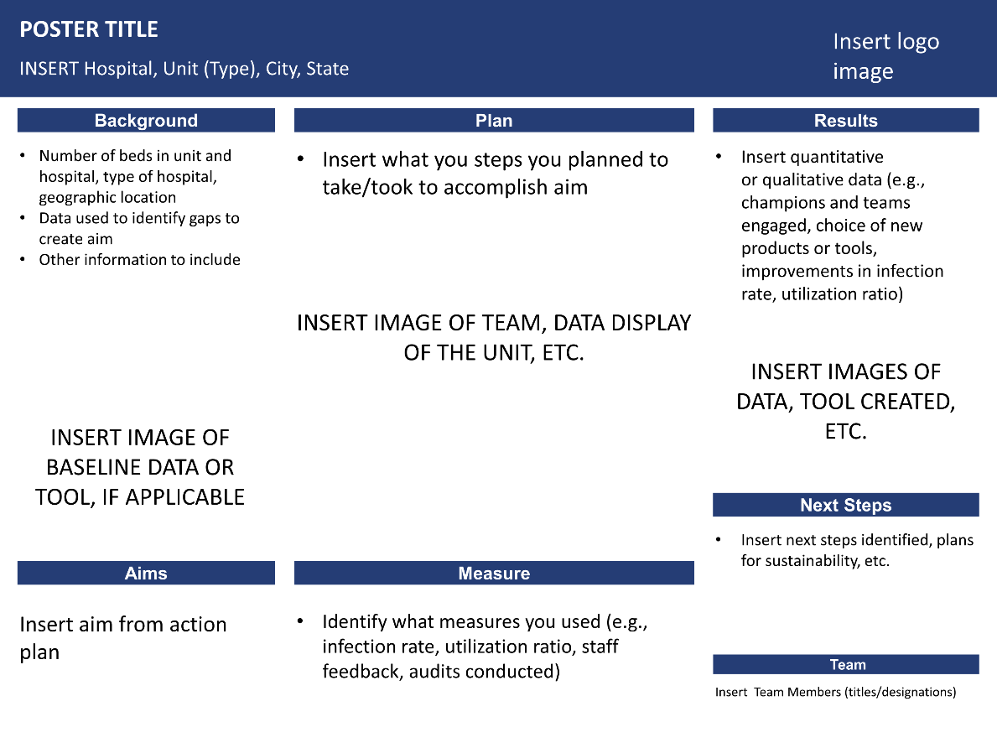

Recognition

Recipients of the *Quest for Excellence* Award will be notified prior to the NHA Annual Convention, which will be held October 21-24, 2025. Award recipients will receive:

* A $2,000 award (NHA and Nebraska Office of Rural Health)
* An engraved plaque presented at the NHA Convention Awards Banquet
* Public recognition in the form of a media release
* A feature article in NHA’s publications

Three awards will be given. One award will be provided to a critical access hospital located in the State of Nebraska, one award will be provided to a non-critical access hospital located in the State of Nebraska and one award will be provided to a rural health clinic located in the State of Nebraska. **We look forward to your participation in the *Quest for Excellence* Award application process. Nebraska’s hospitals and clinics provide high quality care daily. Take a moment to share your quality initiatives with others by submitting your application via email and postal mail no later than August 1, 2025. Applications need to be received via mail to NHA by the due date. Late applications will not be considered.**