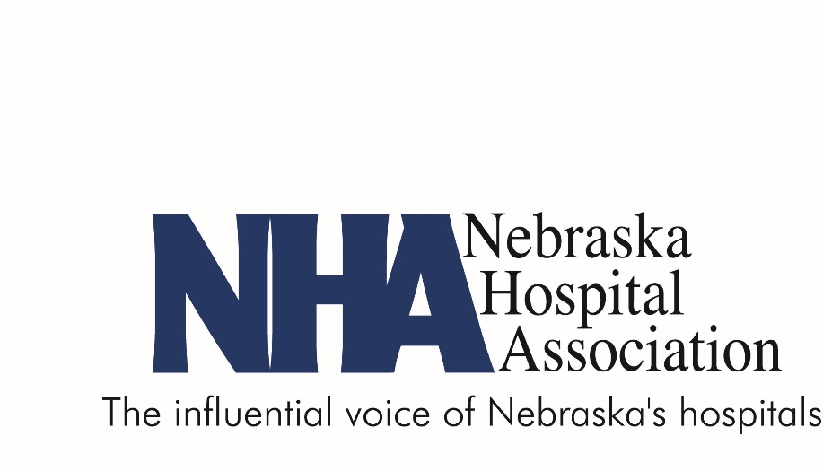

Request for Applications

2020
Quest for Excellence Awards
Nebraska’s Health Care Providers: Leaders in Quality

As a means of recognizing outstanding work in hospital quality and performance improvement in the State of Nebraska, the Nebraska Hospital Association, Nebraska QIO, the Nebraska Health & Human Services’ Office of Rural Health and the Nebraska Association for Healthcare Quality, Risk and Safety have come together to solicit applications for the Quest for Excellence Award. This award is presented during the Nebraska Hospital Association Annual Convention, which is held in the fall.
The Quest for Excellence Award is presented by these organizations to two Nebraska hospitals and one Rural Health Clinic each year to recognize their achievements in improving health care delivery in the areas of quality, performance and patient safety. Created in 2004 to recognize hospitals’ individual and independent efforts, the award is designed to showcase innovative, exemplary and reproducible models of patient care to the health care community.
The need to demonstrate quality improvement is here… so is this incredible opportunity. Why not take the challenge? Regardless of your organization’s past success, when you submit your application for the Quest for Excellence Award, you take another step toward quality and performance excellence.
Statement of Purpose
The Quest for Excellence Award recognizes outstanding efforts to improve hospital and clinic quality and patient care for the people of the State of Nebraska. The award represents the highest level of professional acknowledgement in Nebraska’s hospital and clinic quality improvement arena. The goal of the award is to:
- Recognize outcomes in quality performance practices, capabilities and results.
- Facilitate communication and sharing of best practices information among hospitals and clinics in Nebraska.
- Stimulate innovation, knowledge and learning in the creation of strategies, systems and methods of achieving quality excellence in health care.
Application Content
To participate in the Quest for Excellence Award, an organization must submit an application that addresses the criteria listed below. Entries will be judged by a panel from the four sponsoring organizations. Eligible hospitals and clinics must be able to demonstrate measurable and quantifiable quality improvement. All project descriptions must be double-spaced in 12-point type with 1-inch margins. The document length is limited to 10 pages (excluding cover page and power point). Additional supporting documentation of up to 5 pages may be attached. Submit your entry, including the power point, in electronic format (Word document) plus eight (8) copies. Only one entry per facility is allowed. Include a cover sheet with the following information:
- Name of organization
- Organization address
- Contact name and e-mail address
- Telephone/fax numbers
- Submission date
- Topic

Return via mail no later than August 5, 2020 to:
Margaret Woeppel, Vice President, Quality Initiatives
Nebraska Hospital Association
3255 Salt Creek Circle, Ste. 100
Lincoln, NE 68504-4778
Please include the following categories as you describe your quality improvement activities – include all five categories in your application paper:

Criteria 1 – Leadership/Planning (10 points)
Describe how hospital/clinic leadership guides and sustains your organization by establishing organizational vision, values and performance expectations, with a focus on patients, quality improvement, learning, and managing for innovation. Describe how this project is consistent with your strategic plan.

Criteria 2 – Process of Identifying Need (15 points)
Describe the need in your facility for this initiative; describe why you selected this project and what methods you used to identify the need, e.g., patient/staff/physician satisfaction surveys. What steps did you take to meet your patients’ expectations and requirements? How will this initiative improve the quality of care provided to your patients and your community? Did you integrate your patient/family engagement team? Describe your facility specific issues, as well as providing any applicable national benchmarks or standards.

Criteria 3 – Process Improvement Methods (30 points)
Describe who was involved in the improvement effort, methodology used (PDSA, LEAN, Six Sigma, etc.), how the data was collected, and the process that was used to achieve the results. Describe how you used the data and information to guide your process improvement efforts. This may include clinical, financial and other data such as satisfaction surveys.

Criteria 4 – Results (30 points)
Describe the results including the patient outcomes, process changes and service delivery results, the financial and market performance improvements, leadership, or community improvements that occurred as a result of this project. Projects that demonstrate creativity and innovation will be given greater consideration.

Criteria 5 – Lessons Learned, Replicability, Sustainability (15 points)
Describe the lessons learned from this project; describe how you applied what was learned from this project to other areas in your facility; describe how other facilities could replicate what you did; describe your plans to sustain your gain.

PowerPoint
In addition to your application, please complete and submit your hospital branded PowerPoint slides. The completed template must be no longer than 8 slides. (For example, you may need 2 slides to share your results or describe your processes.) PowerPoints should not contain information not included in the application document.
Recognition
Recipients of the Quest for Excellence Award will be notified prior to the NHA Annual Convention, which will be held October 21-23, 2020. Award recipients will receive:
- A $1,000 award
- A certificate and engraved plaque presented at the NHA Convention Awards Banquet
- Public recognition in the form of a media release
- A feature article in NHA’s publications
Three awards will be given. One award will be provided to a critical access hospital located in the State of Nebraska, one award will be provided to a non-critical access hospital located in the State of Nebraska and one award will be provided to a rural health clinic located in the State of Nebraska. We look forward to your participation in the Quest for Excellence Award. Nebraska’s hospitals and clinics provide high quality care on a daily basis. Take a moment to share your quality initiatives with others by submitting your application via mail no later than August 5, 2020. Applications need to be received via mail to NHA by the due date. Late applications will not be considered.

