Dear Participant in the Nebraska Critical Access Hospitals Conference on Quality: High Reliability Critical Access Hospitals on November 14-15, 2017:
Thank you for your participation in our educational activities. Now, please complete the attestation form at http://www.go2certificate.com to receive the contact hours you deserve. This activity awards up to 9.25 contact hours for nurses and quality professionals.

We recommend the use of Chrome for an optimal portal experience.

Please visit http://www.go2certificate.com
Enter Access Code: 439-NECAH
Enter your email address
Click the NEXT button.

The portal will be active until November 30, 2017 at 11:59 pm ET. Please claim your certificate(s) by this date/time.

In future visits, the system automatically recognizes your account based on your email address. It will ask you to enter your own created password after you have entered the Access Code and your email address.

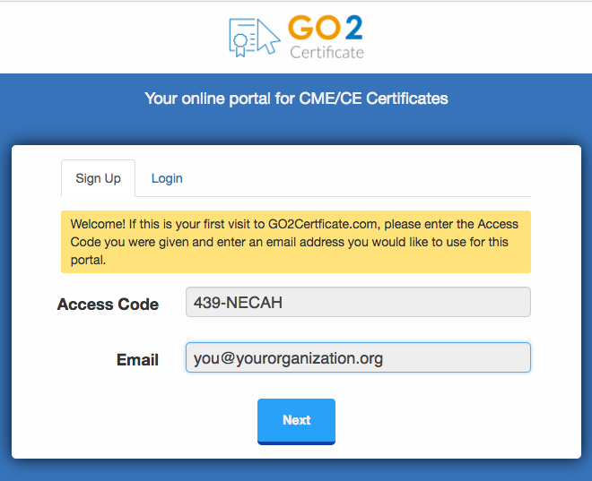

- Complete demographic information and setup a password.

Click the NEXT button.
- Select the session(s) you attended by clicking the box to the left of the session title. Only one session may be selected in time blocks with concurrent sessions. You cannot earn credit twice for the same session. Be sure to select a unique session in each of the repeat
blocks at 1:00 – 2:15 pm CT and 2:30 – 3:45 pm CT on 11/14/17.

Click the NEXT button.
Your conference evaluations will load.

- Complete the Conference Evaluation and advance the screens by using the NEXT button. Your input is invaluable. At the end of the evaluations, please click the SUBMIT button.

- Please confirm how you would like your name to appear the certificate. Include your professional credentials if you wish.
Please select the box requesting the accreditation you wish to earn. Multiple selections are acceptable.

Click the NEXT button.

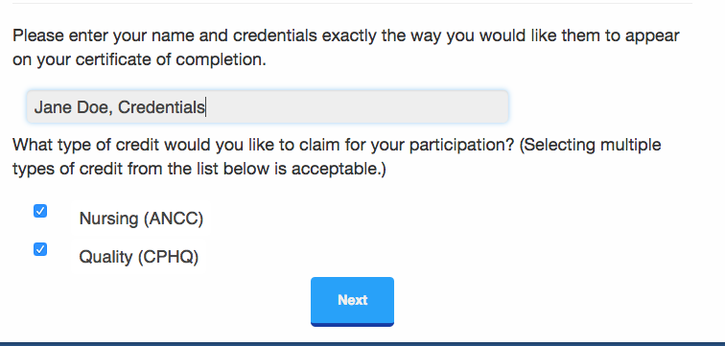

- Confirm your hours.
A list will appear with the sessions you selected and the hours awarded for the accreditation(s) you wish to earn. Confirm your hours and click NEXT button.

- Click VIEW button(s) to open and print your certificate(s). Once you click the VIEW button you will also have the option to email your certificate to yourself. In addition, your certificate will be hosted on our website and can be accessed as many times as you like using the “Login” option on the main page.

Please email info@axismeded.com for assistance. Thank you.

