Important Dates

3/19/25 | Start emailing your Evaluators, please see the sample email below  - This email prepares your Evaluators for the upcoming invitation email that they will receive and informs them why they are receiving it
3/24/25 | You will receive an email from cpeservices@bellevue.edu with your login and password  - Start uploading your Evaluators into Qualtrics using the instructions below  - You can also start completing your self-evaluation at this time
3/27/25 | Evaluators due/Need to be uploaded in Qualtrics
3/28/25 | An email will be sent to all Evaluators with their login and password; Evaluators will begin completing their evaluations
4/2/25 & 4/4/25 | A reminder email will be sent to everyone who has not completed their assigned assessments
4/7/25 | Assessment due date
4/9/25 | Retrieve your report using the instructions below

Helpful Hints
- If your password is “Omitted for Privacy” this means you have setup a password in the past. Instructions on how to reset your password are on page 10

- Google Chrome is the best browser to use, if you are having issues please try using Google Chrome

- If you are still having issues logging in or with your browser please email cpeservices@bellevue.edu. Please provide as much information as possible and screenshots are very helpful

- Sample Evaluator Email
Hello!
I need your assistance, please! As a participant in this year’s Nebraska Hospital Association’s Leadership Institute, I am working on further developing my leadership skills. I respectfully request that you help me by completing a short survey about my leadership capabilities. Your honest and candid feedback is very important to my development.

You will receive an email from cpeservices@bellevue.edu that includes a link to a short survey. The survey will take you about 10 minutes to complete. I encourage you to write additional comments in the open-ended portion of each statement.

I thank you in advance for your objective evaluation of my abilities. Your identity will be 100% anonymous.
Thank you again for your continued support!
Sincerely,
[replace this with your name]

- Choosing Your Nominations (People to Evaluate You)
Compile a list of 4 – 10 Evaluators that you would like to evaluate you including the following information:
- First name
- Last name
- Email address
- Relationship to YOU
- Manager – Someone you report to
- Direct Report – Someone that reports to you
- Peer – Someone you work with that you do not report to and does not report to you
- 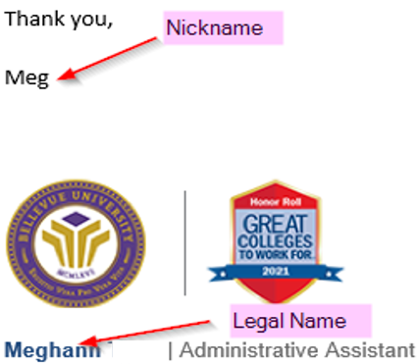 | TIP - Use the first and last name that is used on your nominations email block, NOT a nickname  - This helps to reduce duplicate entries in the directory using the same email address  - When there are duplicate entries with the same email address the system will NOT send out invitations if the names do NOT match  Example – Everyone knows me as Meg but you would use Meghann in the evaluation for consistency
 | Once you have complied your list of people to evaluate you move on to “Logging in for the First Time”

- Logging in for the First Time
 | - You will receive an invitation email from cpeservices@bellevue.edu with your log on and password when the evaluation begins
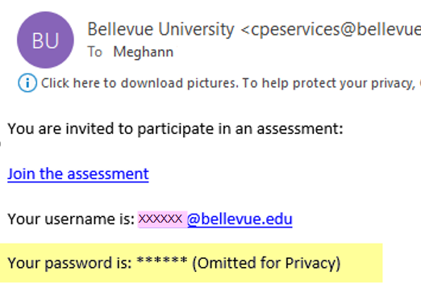 | - If you have completed a survey in the past, you will receive an email with your user name and your password will be omitted.  - Follow the link in the email to Qualtrics by clicking “join assessment”  - The best browser is Google Chrome  - If you do not remember the password, you have the option to reset the password yourself or email cpeservices@bellevue.edu and request that we reset the password for you
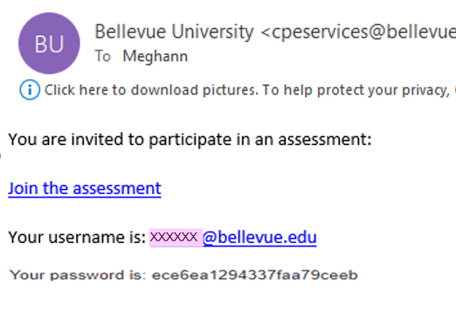 | If you have not completed a survey in the past you will receive an email with your user name and password  - Follow the link in the email to Qualtrics by clicking “join assessment”  - The best browser is Google Chrome
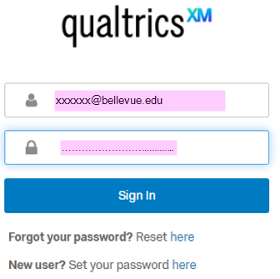 | - Sign into Qualtrics  - Enter the username from the invitation email  - Enter password from the invitation email/previous password  - Click “Sign In”
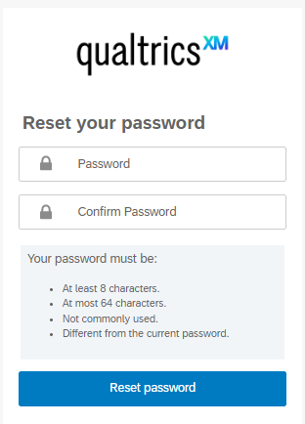 | - If this is the first assessment you are completing you will be required to reset your password  - Enter new password  - Confirm new password  - Click “Reset password”
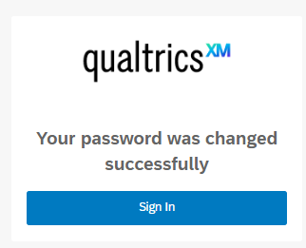 | - Once your password has been reset click “Sign In”

Adding Your Nominations to Evaluation
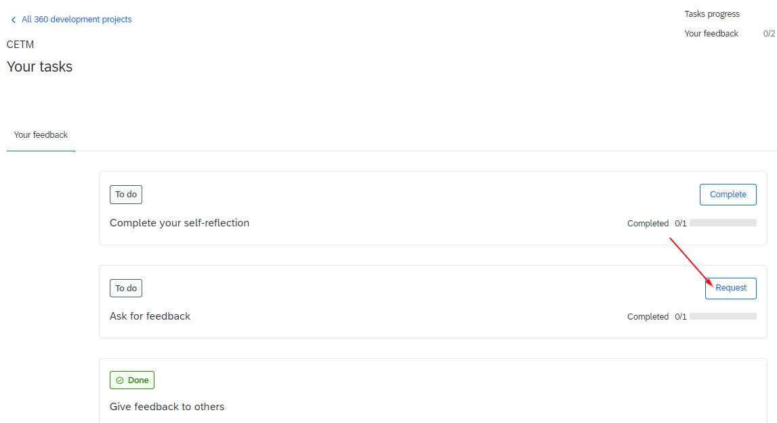 | - When log in you will be taken to your home screen  - Click “Request” in the “Ask for feedback” task box
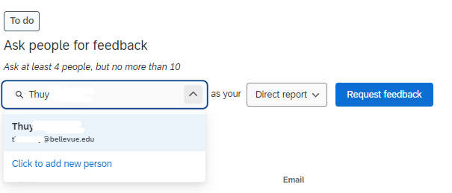 | - Determine if the person is in the directory by typing the person’s name you would like to evaluate you  - If the person is already in the directory, their name will show up  - Click on their name  - Go to #1  - If the person isn’t in the directory, skip to #2
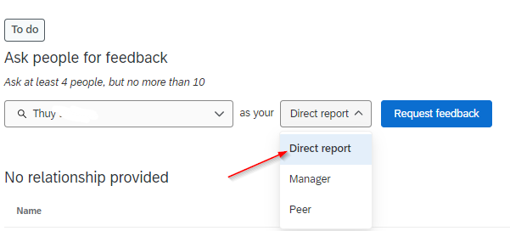 | - 1. In the directory  - Choose YOUR relationship to the person evaluating you  - Example – Thuy reports to me, Thuy is my Direct Report
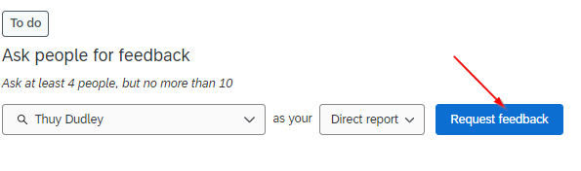 | - Click on “Request feedback”  - Once you have clicked “request feedback,” an email with a login and password will be sent to your Evaluator
 | - Continue adding your Evaluators until you have no less than 4 but no more than 10 Evaluators
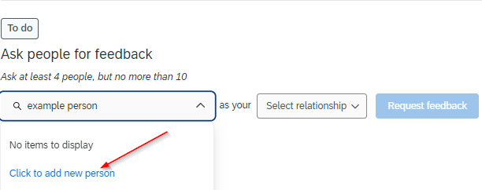 | - 2. Not in the directory  - Type their first and last name  - Click on “Click to add new person”
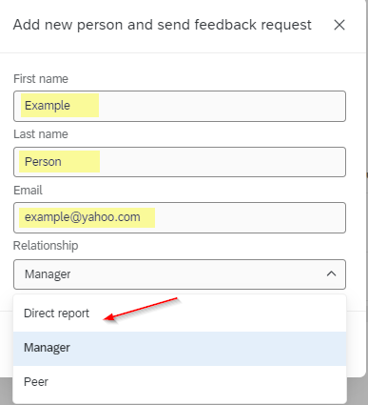 | Fill in the highlighted information  - First name  - Last name  - Email  - Relationship  - Example – Example Person reports to me, Example Person is my Direct Report
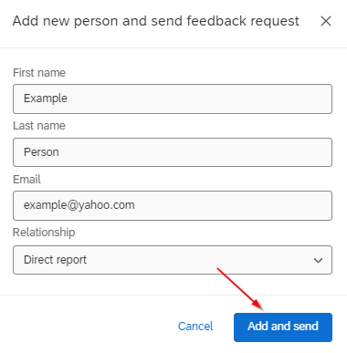 | - Once all information has been entered  - Click “Add and send”  − Once you have clicked “Add and send,” an email with a login and password will be sent to your Evaluator
 | - Continue adding your Evaluators until you have no less than 4 but no more than 10 Evaluators
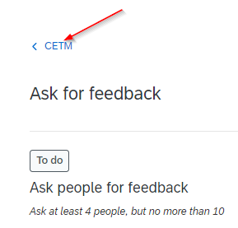 | - Click on the “Survey Name” to return to the main menu

Complete Evaluations
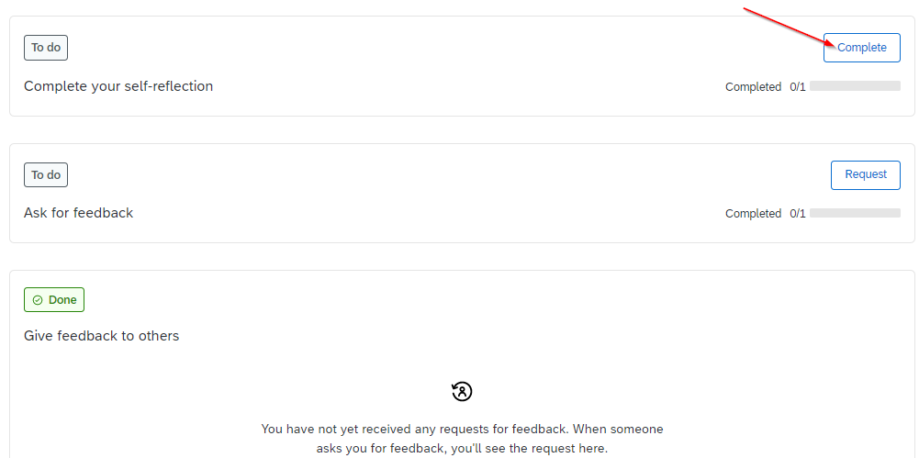 | - From the main menu, click “Complete” in the Complete your self-reflection task  - This task will show as complete once the evaluation is complete  - If you stop in the middle of an assessment your progress will automatically be saved
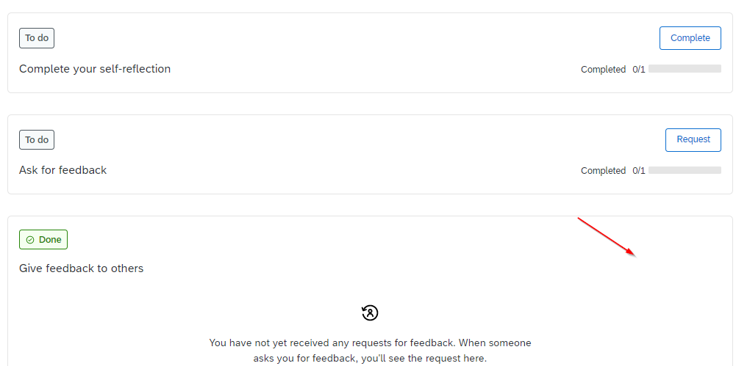 | - If someone has requested that you evaluate them, you will see a box that says “Complete”  - Click “Complete” in the “Give feedback to others” task  - This task will show as complete once the evaluation is complete  - If you stop in the middle of an assessment your progress will automatically be saved

Accessing Your Report
 | The date your report will be available is at the top of the instructions
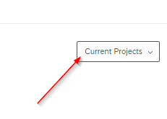 | Log back into your Qualtrics portal and click on the “Current Projects” dropdown
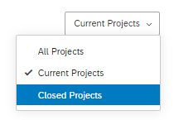 | Choose “Closed Projects”
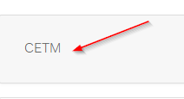 | Choose the project name  Your Project Name is  NHA – 2024
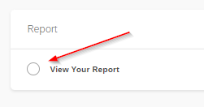 | Scroll down to the Report section and choose “View Your Report”
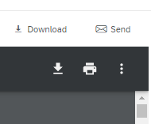 | Once your report has opened you have the option to download, email, or print your report

Resetting Your Password
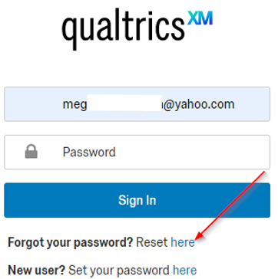 | From the log in page enter your email address  Next to Forgot your password? click on “Here”
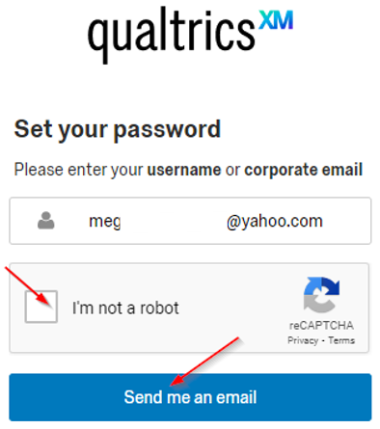 | Choose I’m not a robot  And then click ”Send Me an Email”
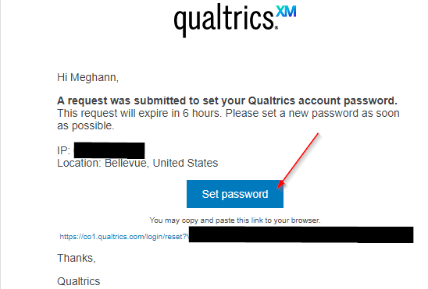 | Go to your email address and locate the email from Qualtrics (updates@notifications.qualtrics.com)  Click on “Set Password”  You will be taken back to the Qualtrics portal where you can reset your password  If you are still having issues logging in please email cpeservices@bellevue.edu

